WEEK 6: EXERCISE 6
Database System and Cloud (BERR2243)


Provided by:
Group Member | Id No.
Ahmad Muhaimin Azeem Bin Adri Wafik | B122310496, 2 BERR S2
Syafiq Iman Bin Suhaimi | B122310218, 2 BERR S2
Ery Fahrhan Bin Mohamed Ali | B122310448, 2 BERR S2

1. Token Usage:
o What happens if you omit the Authorization header when
accessing /admin/users/{id}?.
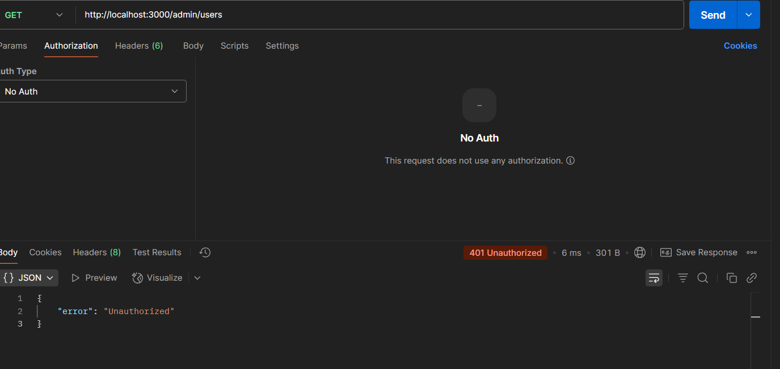

o What error occurs if you use an expired token?


o What happens if the rides collection is empty?
Paste the token generated to https://jwt.io, and discuss the content
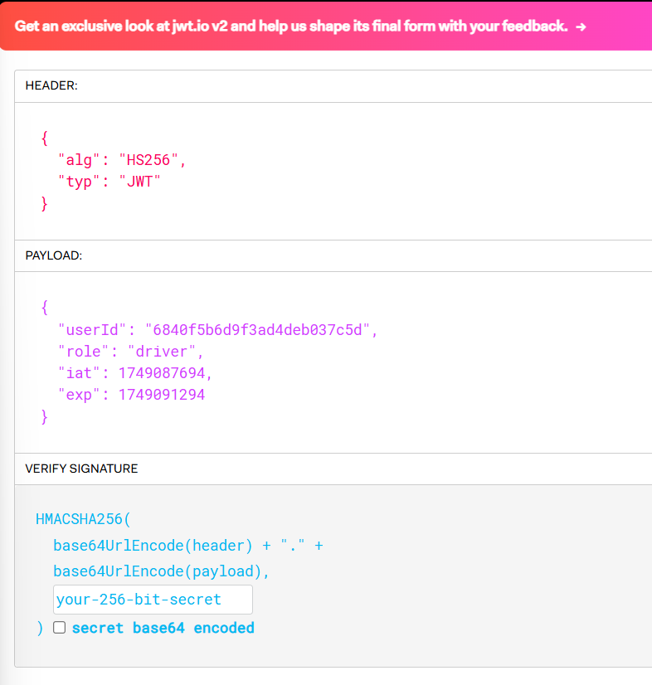

Header: It specifies the signing algorithm (HS256) and token type (JWT).
Payload: Contains the claims:
userId: The unique ID of the user.
role: The role of the user (driver in this case).
iat: The issued-at timestamp, showing when the token was created.
exp: The expiration timestamp, showing when the token will expire.
Signature: Ensures the token’s integrity by verifying it hasn’t been altered.

2. Role Restrictions:
o If a customer-role user tries to access /admin/users/{id}, what status
code is returned?
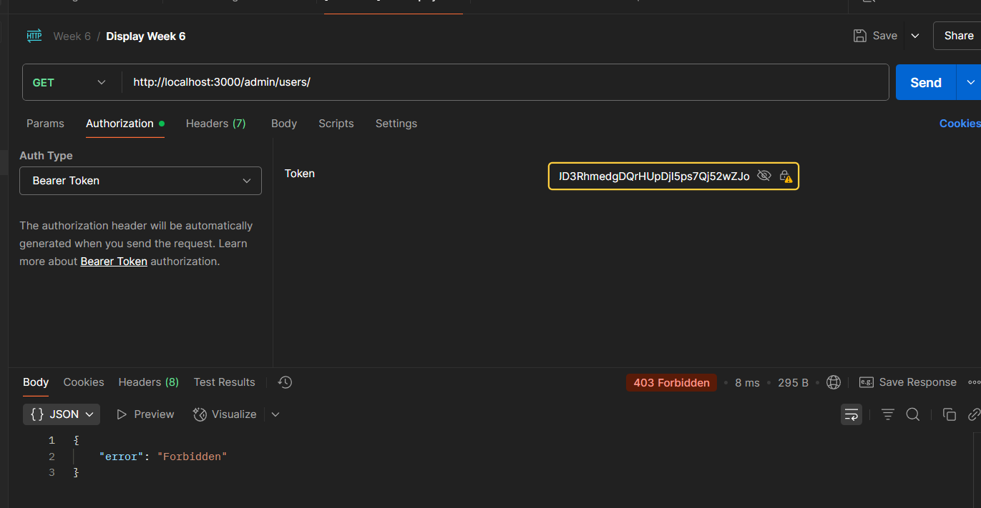

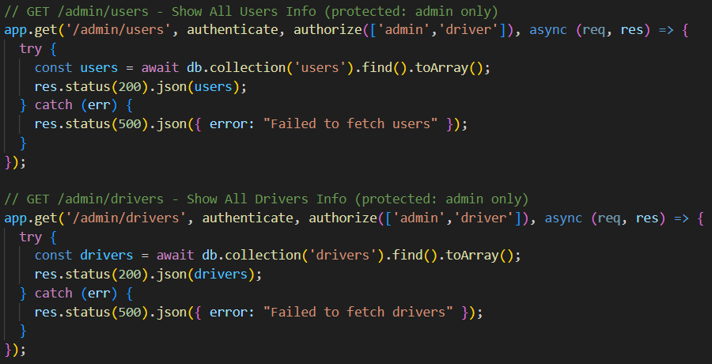
o How would you modify the middleware to allowboth admin and driver roles to access an endpoint?

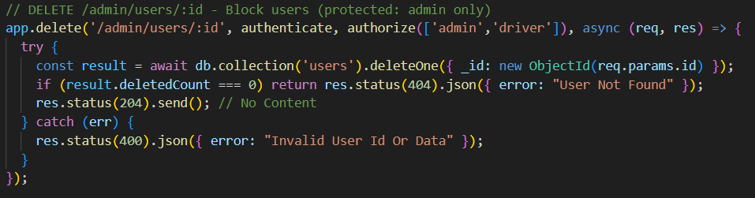

3. Security:
o Why is the JWT token sent in the Authorization header instead of the
request body?
The Authorization header is more secure than placing the token in the request body or URL parameters because HTTP headers are less likely to be logged or exposed in transit compared to body data or URL query strings.

o How does password hashing protect user data in a breach?
Password hashing makes passwords unrecoverable in the event of a compromise, hence protecting user data. It turns plaintext passwords into hashed values, which are one-way, irreversible, and frequently salted for further uniqueness. Even if hashed passwords are taken during a breach, they cannot be easily reversed to reveal the original password, making it far more difficult for attackers to get access to user accounts.

4. Postman Testing:
o What is the purpose of the Bearer keyword in the Authorization header?

The "Bearer" keyword in the Authorization header is part of the OAuth 2.0 standard and is used to indicate that the token being sent is a bearer token.
A bearer token is a type of access token that allows the bearer (whoever holds the token) to access protected resources without needing further authentication.

o How would you test a scenario where a user enters an incorrect password?
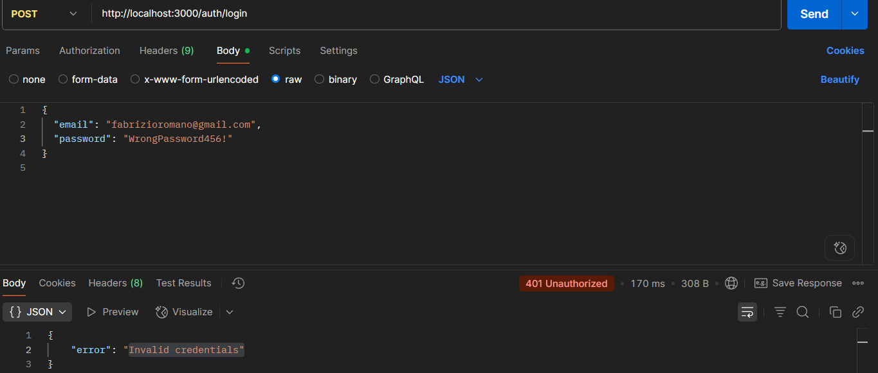

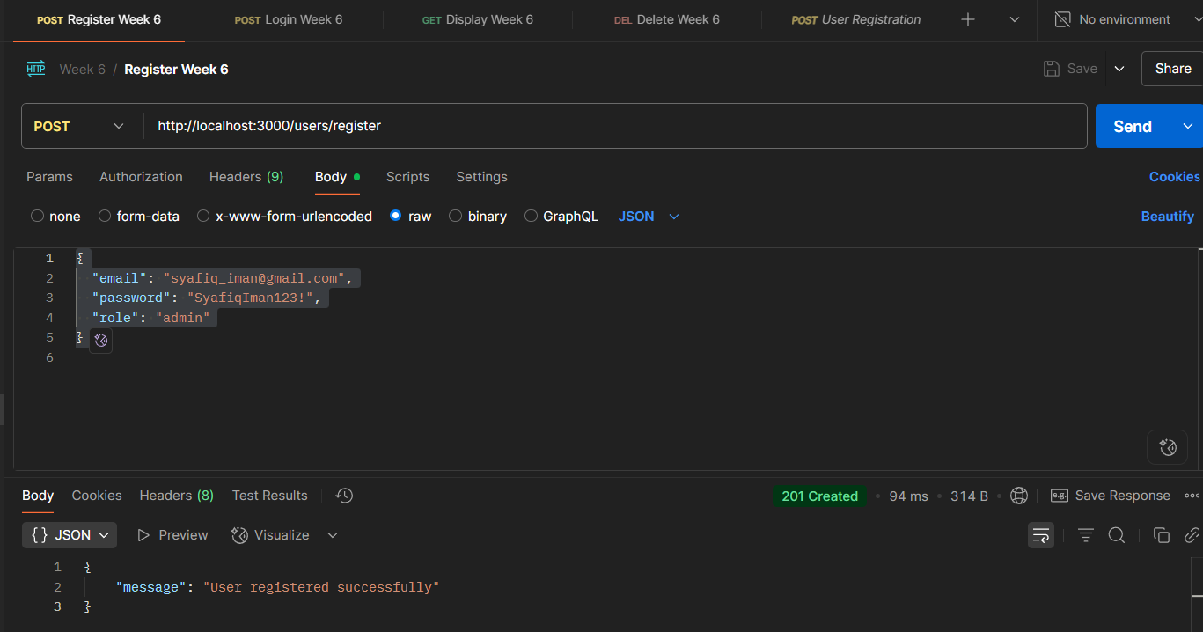
SCREENSHOTS FOR POSTMAN
Successful Registration
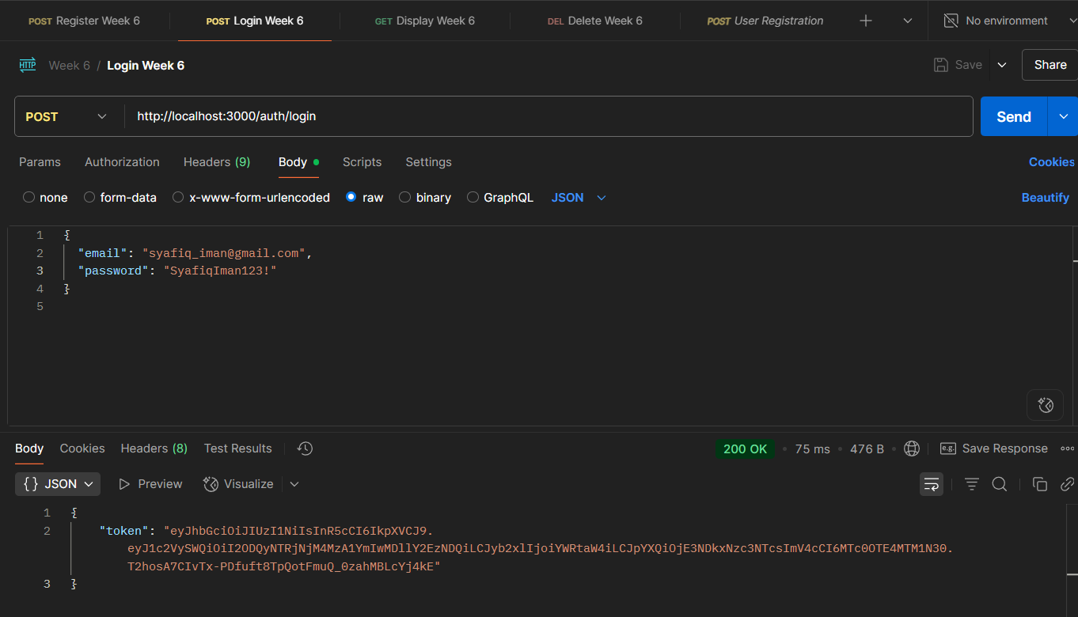
Successful Log In

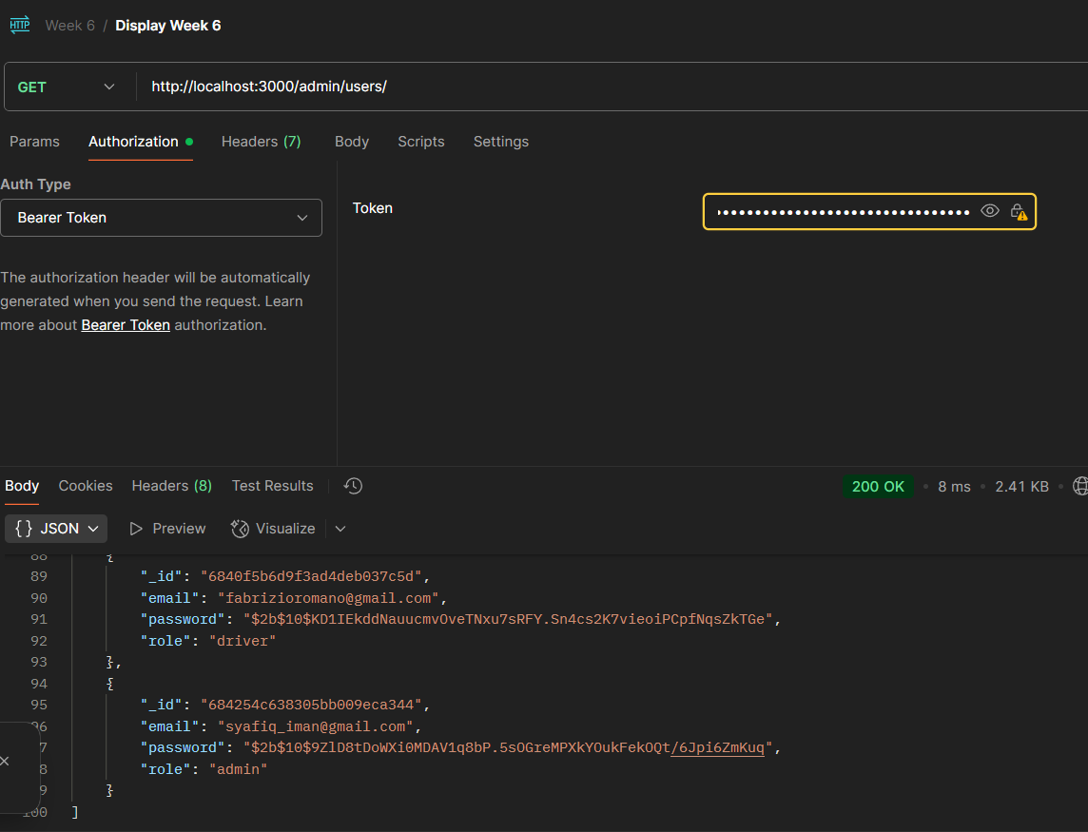

Successful Display of All Authorized Users

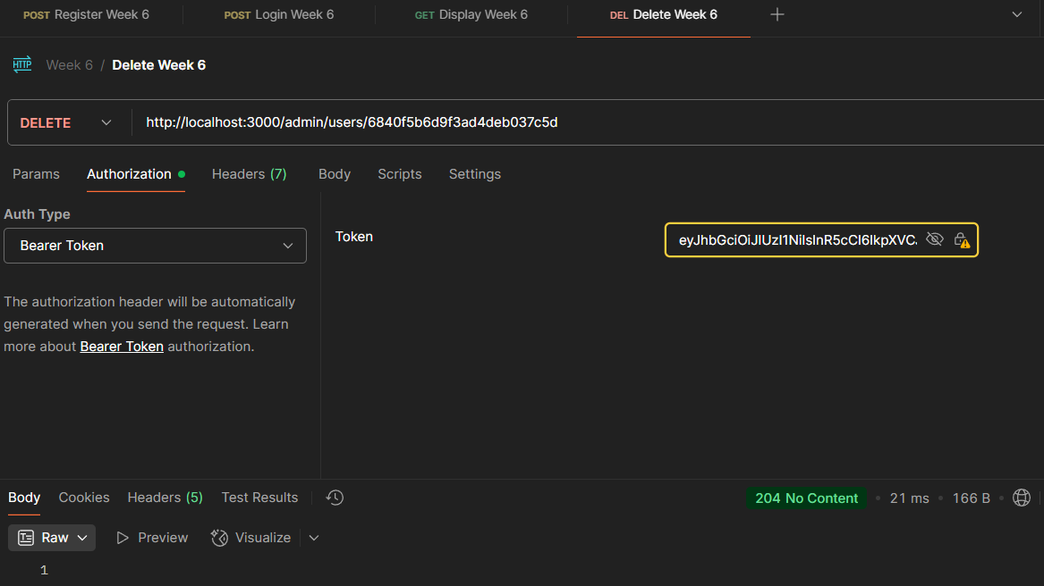
Successful Deleting User

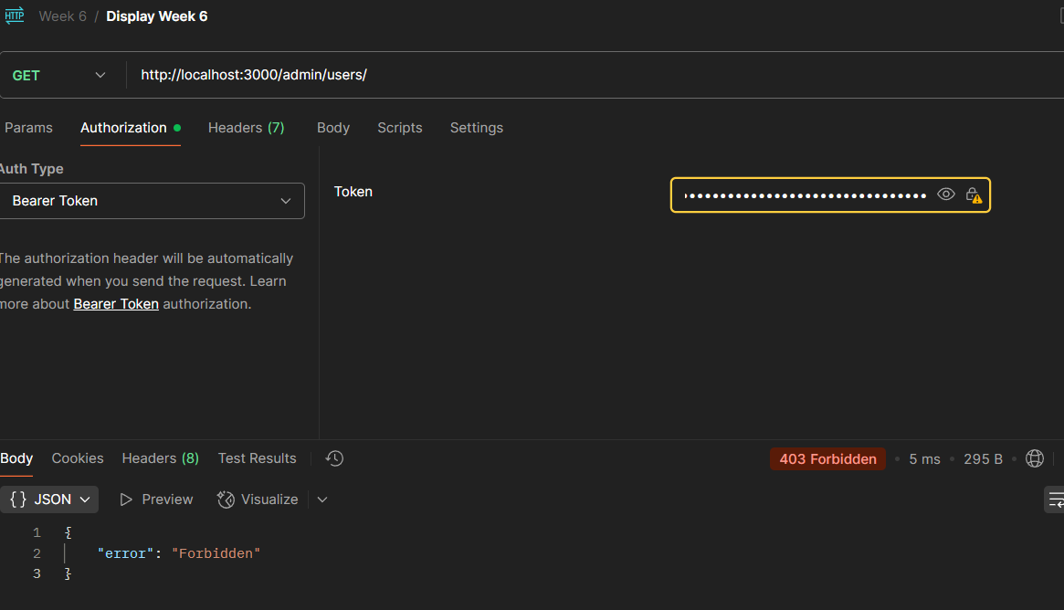
Unsuccessful Display of All Users

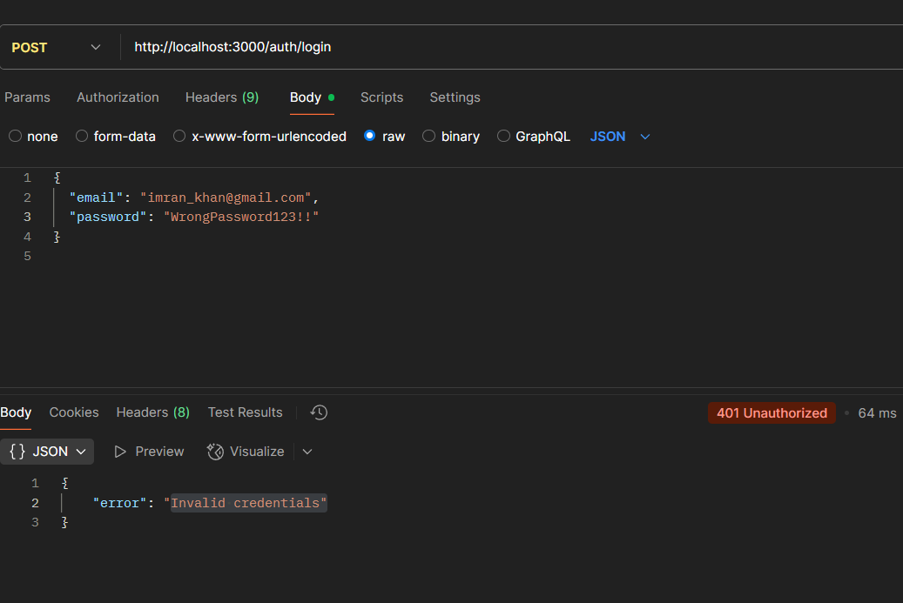

Unsuccessful Log In because of Wrong Password
Link to GitHub Repository:
https://github.com/Ahmad-Azeem/min-iman/tree/week6

